### Setting up the environment at client side

#### Setting up for computer

* The client devices need to have one of the following browsers to access the website:
* Google Chrome.
* Firefox.

#### Setting up for Android devices

* Change setting to install unknown source apk.
* Connect to the same network as the server

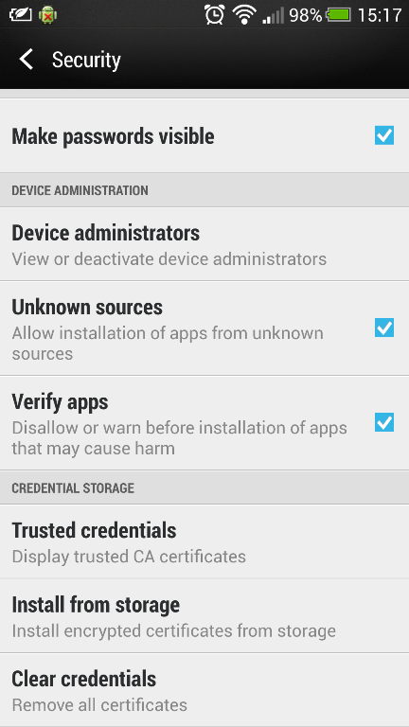 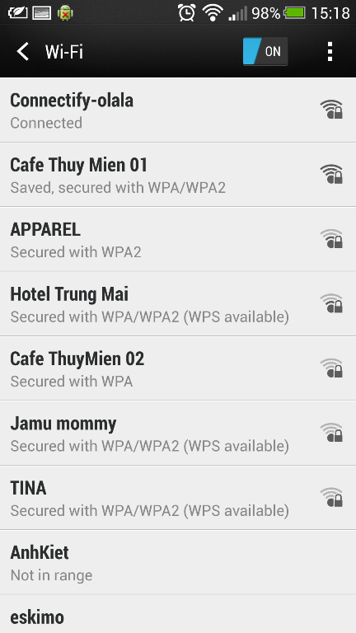

**Figure 108: Change Settings**

* Use browser and go to address <http://www.mediafire.com/download/ka1l9qh5en3sey4/SmartB.apk>, download the apk file.

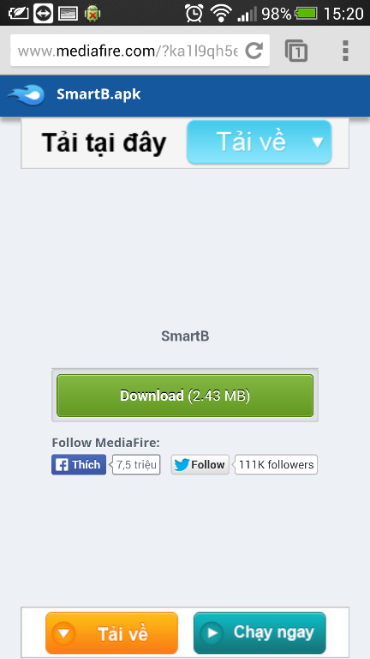

**Figure 109: Download app**

Click Install to install the app.

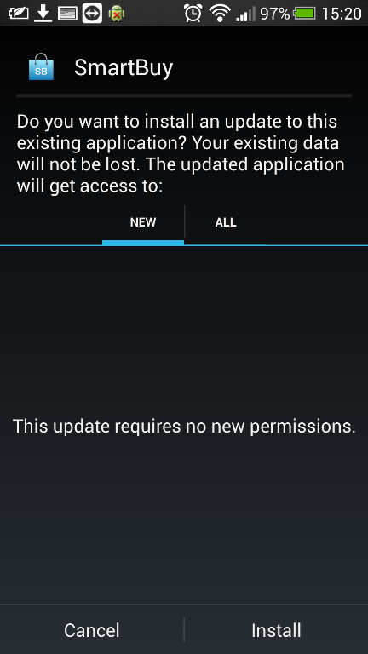 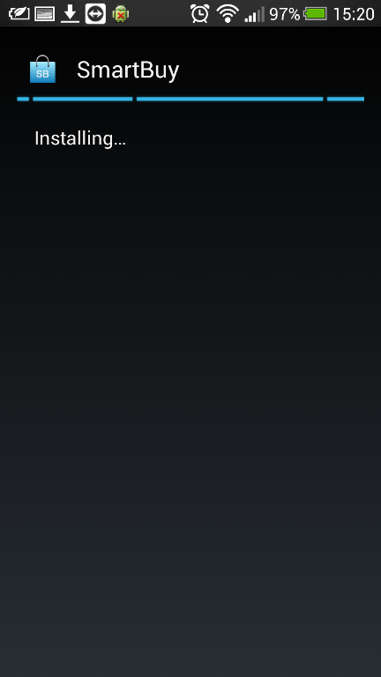

**Figure 110: Install App**